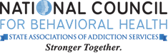

National Council for Behavioral Health operates Mental Health First Aid in the USA. The National Council for Behavioral Health, the Maryland Department of Health and Mental Hygiene, and the Missouri Department of Mental Health founded Mental Health First Aid USA.

**ncbh_instructor2name**

Instructor

**ncbh_instructoridname**

Instructor

First Aid USA

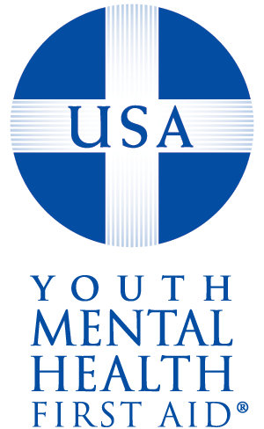

Date

This certificate expires on: 4/6/2022

This certificate became effective on: 4/6/2019

Date

Youth Mental Health

**Juliana Hernandez**

Has completed the 8-hour course and is now certified in

Youth - N/A

Mental Health First Aid USA

And has been trained to provide initial help to young people experiencing

problems such as depression, anxiety disorders, psychosis, and substance use disorders.

